* [https://docs.microsoft.com/en-us/azure/virtual-machine-scale-sets/overviewhttps://docs.microsoft.com/en-us/azure/virtual-machine-scale-sets/overview](https://docs.microsoft.com/en-us/azure/virtual-machine-scale-sets/overviewhttps:/docs.microsoft.com/en-us/azure/virtual-machine-scale-sets/overview)
* Setup dynamic scaling rules in a set of virtual machines.
* It can support up to 1000 vms
* 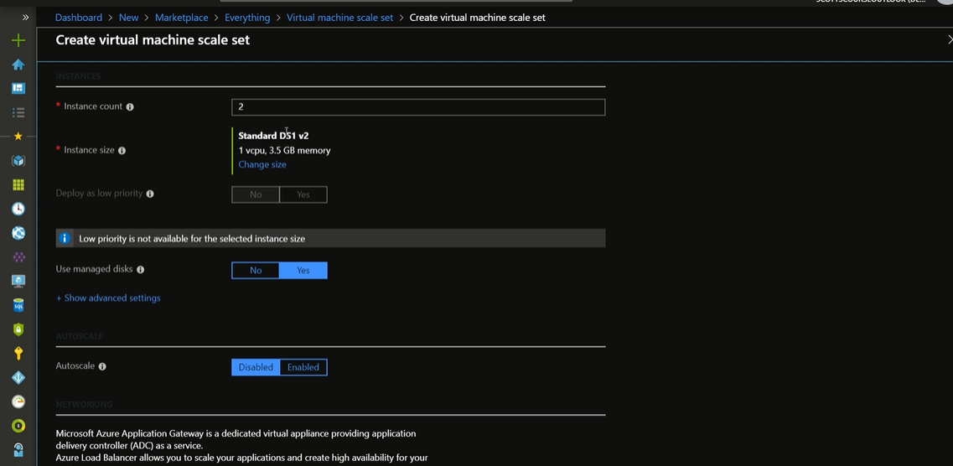
* Enable or disable auto scaling.
* Auto scale the lower and upper limit while creating the VMSS and according to the time

**Scaling a VM**

* Go to size and change the size of the VM.
* Re-size the VM
* Load Balancing is provided for virtual machines.

**Transient Faults**

* Service Downtime and slowdowns
* Pay attention to the availability.
* Scaling up and Scaling down the con-figs need to take care the application downtime
* Retry Back-off logic
* Use of queues and database and other messaging systems, do not have a tightly coupled application.
* Do error handling while making an API calls gracefully.
* https://github.com/Azure-Samples/app-service-dotnet-scale-web-apps